

Target: ___/ 86 or ____ % 👍 👎

86

Year 9 HASS - History

***Assessment 1: In Class Content Assessment (7% weighting)***

Name: **MARKING KEY**

**Time: 3 minutes reading time and 45 minutes working time.**

**Multiple Choice** (10 marks)

Circle the correct answer to the following questions **(1 mark each)**

**1** **The most significant factor that contributed to the Agricultural Revolution was:**

**A** The use of cotton

**B** The steam engine

**C** The population explosion

**D** The slave trade

**2 The most significant factor that contributed to the Industrial Revolution was:**

**A** The demand for cloth

**B** The demand for coal

**C** The canals

**D** The railways

**3 Turnpike Trusts were created to help with the maintenance of:**

**A** Mines

**B** Roads

**C** Canals

**D** Railways

**4 An example of farming technology would be:**

**A** The threshing machine

**B** The Spinning Jenny

**C** Newcomen’s engine

**D** The Mule

**5**. **The term ‘Trappers’ refers to which aspect of the Industrial Revolution era?**

**A** The mining industry

**B** The textile industry

**C** The railway industry

**D** The canal industry

**6** **The Industrial Revolution began in which country?**

**A** America

**B** France

**C** Britain

**D** Australia

**7 The term ‘Hew’ refers to those that:**

**A** collected loose pieces of cloth underneath the moving parts of machines

**B** repaired broken threads running through the moving parts of machines

**C** collected items in the mud of rivers to sell to others

**D** cut away at the coal face to collect coal

**8 The term ‘Piecers’ refers to children who:**

**A** collected loose pieces of cloth underneath the moving parts of machines

**B** repaired broken threads running through the moving parts of machines

**C** collected items in the mud of rivers to sell to others

**D** cut away at the coal face to collect coal

**9**  **The term ‘Scavengers’ refers to children who?**

**A** collected loose pieces of cloth underneath the moving parts of machines

**B** repaired broken threads running through the moving parts of machines

**C** collected items in the mud of rivers to sell to others

**D** cut away at the coal face to collect coal

**10 The term ‘Hurriers’ refers to children who:**

**A** dug the canals

**B** rushed to find items hidden in the mud

**C** chased slower chimney sweeps up the chimneys

**D** carried or pushed or pulled coal to the surface

**Short Responses**

1. **List the 8 key concepts of History.**

***Sources***  ***Evidence***

***Cause & Effect***  ***Continuity & Change***

***Perspective***  ***Significance***

***Empathy***  ***Contestability***

**(8 marks)**

1. **Read the descriptions below and write the correct key concept of history that relate to each.**
2. Items of information from the past: ***Sources***
3. Viewpoints: ***Perspective***
4. The importance of something: ***Significance***
5. Understanding how others feel or felt: ***Empathy***
6. Sources that answer questions about the past: ***Evidence***
7. Patterns in history that have remained the same; patterns that show an alteration in behaviour:

***Continuity & Change***

1. Factors that make things happen and the results of those changes: ***Cause & Effect***
2. To argue/ challenge something: ***Contestability***  **(8 marks)**
3. **Provide a strong reason why we should study and understand History.** ***To recognise and understand where we have come from to learn more about ourselves/ To learn about other cultures and backgrounds to understand others/ To learn about mistakes in the past to avoid repeating them/ To identify trends and patterns in history.*** **(2 marks)**
4. **Complete the following sentences:**
5. A primary source is something that was created ***during the period of study, such as a diary or canal bridge***
6. A secondary source is something that was created ***after the period of study by another historian, such as a book, replica clothing, or documentary.***
7. A historical theory or idea to be proved is often called a ***hypothesis.***
8. A source that gives an insight into the past, answers a historical question, or acts as evidence of an event or idea, is said to be ***useful*** to a historian?
9. When a source is said to be one-sided or only strongly represents one perspective, it is said to be ***bias*** **(5 marks)**
10. 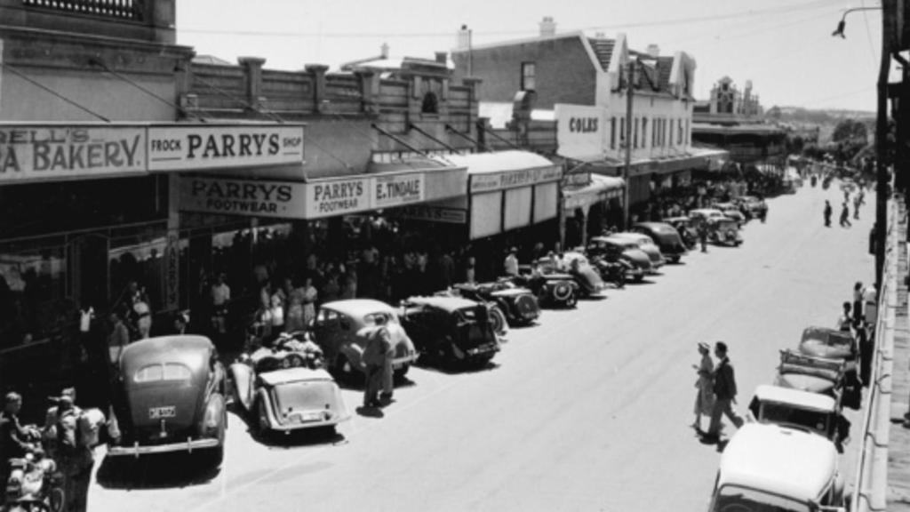**Examine Source 1, the image of Herald Street in Narrogin. Identify two aspects of continuity and identify two aspects of change.**

**Continuity *ANY OF THE FOLLOWING TWO:***

***The street layout; people and cars;*  *some stores, etc.***

**(2 marks)**

**Change:** ***ANY OF THE FOLLOWING TWO:***

***Angle parking to parallel parking; some stores have changed; the model of car; people’s clothing styles; the road surface/ road markings; the street appears much busier than today.***

**(2 marks)**

1. **Define the term ‘Cottage Industry’ and give an example.** ***The cottage industry was based on a home dweller working during the day on a simple machine (1 mark ) such as a spinning or weaving machine to create clothing out of wool, and later cotton (1 mark ) , for themselves or for the wider village community. This became insufficient in production when the demand for clothing increased due to population increases by the mid 1700’s. (1 mark )***

**(2 marks)**

1. **Describe the open field system prior to the Agricultural Revolution. (3 marks)**

***The open field system was based upon a three-year crop rotation of wheat or oats, barley, and a field left as fallow (1 mark) The fallow field was left unused to allow nutrients to replenish (1 mark). Each family in the community were allocated strips within each field to grow food for themselves and often to give a percentage to the overall landowner (1 mark ). A common area to collect firewood and graze animals was also provided (1 mark ).***

1. **Identify three drawbacks within the open field system that made it less efficient.**

**Any of the following three:**

* ***Time was wasted travelling between strips***
* ***Diseases and pests spread easily due to the travelling nature of the strip system***
* ***Little allowance was given to experiment or grow different crops***
* ***Seed was wasted by being broadcast and lost to wind or birds***
* ***Pathways between strips were unproductive***
* ***The fallow field left a third of the land unused***

**(3 marks)**

1. **List four improvements that were made to agriculture that improved efficiency.**

* ***Selective breeding of animals***
* ***Enclosures around fields and***
* ***Crop rotations using four fields***
* ***Technology***

**(4 marks)**

1. **List the three common forms of power used prior to** (before) **the use of steam power.**

* ***Horse power***
* ***Water power***
* ***Wind power***

**(3 marks)**

**Using your knowledge from the time period, explain the impact on society that the development of steam engines made.** ***The steam engine revolutionised industry and allowed factories to develop because bigger and more efficient machines could be powered with steam power. (1 mark) These factories could be built almost anywhere, not always needing to be near a water course or windmill.(1 mark) Steam power also promoted the development of the railways that transported goods a lot quicker than in the past. (1 mark) These railways were also adapted to carry passengers, making travel a lot easier for many people. (1 mark)*  Steam engines were used to pump water from coal mines allowing deeper shafts to be dug and more coal to be accessed, in turn promoting the use of steam power due to its need for coal as a fuel. *(1 mark )***

**(4 marks)**

1. **Create a flow chart of cause of effect of the transformation from the cottage industry to the development of factories involving textiles.** Eight marks will be looking for 8 events and changes. **(8 marks)**

**Increased population  Demand for cloth  Invention of more efficient machines **

**Cottage industry too small  Need to build factories  Migration from rural to towns and cities**

**Towns and cities grow  Worker’s income increases  Cotton becomes more desirable**

** The slave trade increases  More resources become available  More workers required**

** Child labour becomes more common  Families grow in size to gain greater income **

**Population increase  Demand increases – and so on.**

1. **Outline the reason why African slaves were used as a labour force in the New World (The Americas).**

***Native Americans were susceptible to European diseases and not able to sustain the required workforce. (1 mark) Africans had been exposed to European diseases and found to be largely immune and therefore could fill the labour gap. (1 mark) Due to racial differences and a belief in superiority, Europeans felt they had a right to subjugate perceived lesser peoples. (1 mark) There was a great demand for cotton, tobacco and sugar that desperately needed a workforce. (1 mark)***

**(2 marks)**

1. **Briefly describe the term ‘Triangular Trade’** **in relation to your history studies.**

***Triangular trade refers to transport of goods and trinkets to Africa (1 mark); the purchase of captured slaves and their movement to the Americas (1 mark); the sale of the slaves to plantation owners and the purchase of cotton, tobacco and sugar for its transport to Europe. (1 mark)***

**(3 marks)**

1. **Briefly describe the term ‘Scramble’** **in relation to your history studies.**

***Scramble refers to a form of sale of slaves in the Americas. (1 mark) Plantation owners would pre-purchase a quantity of slaves at a specific price (1 mark); and then at a given signal all those who purchased a number of slaves, would enter the area and grab as many of their allotted slaves as they could in a rush (1 mark) often separating whole families and/ or parents from their children (1 mark)***  **(3 marks)**

1. **Select one of the following:** Roads, Canals, Railways, Shipping **and explain the historical context** (who, what, when, where, causes and effects).  **(4 marks)**

I have selected: ______________________________________________________________

**Students should clearly indicate which topic they are selecting and then identify at least four aspects relating to that topic connected within the range of ‘**who, what, when, where, causes and effects’

1. **Explain the significance** (importance) **of coal during the Industrial Revolution. (4 marks)**

***Coal was significant during the Industrial Revolution because it was the primary source of fuel to power the many steam engines that drove the machines in the cotton mills, the engines in the trains and the ships. (1 mark) Coal mining employed many people, increasing the spending power of the population (1 mark) The use of carts on tracks to move coal led to the use of steam engines in railways and the consequent railway network around Britain and then the world. (1 mark) Coal became a cheaper fuel to use in households, yet added to pollution and ill health for many. (1 mark)***

1. **Using empathy, write a daily diary entry from the perspective of a child during the Industrial Revolution that describes what they saw, heard and felt whilst working as child labour. (6 marks)**

**Students should write a convincing entry that indicates they understand what child labour during the Industrial revolution involved. Marks can be given for the description of a specific child’s role in a factory, mine, chimney, on a ship, or around the sewers and rivers. Individual marks can also be given for each description that indicates fear, personal danger, dirt, unhygienic conditions, noise levels, working hours, young age levels, etc.**